

**DEPARTMENT OF MODERN LANGUAGES & LINGUISTICS**

**M.A. IN GERMAN/GERMAN STUDIES**

**(Graduate Teaching Assistantships available)**

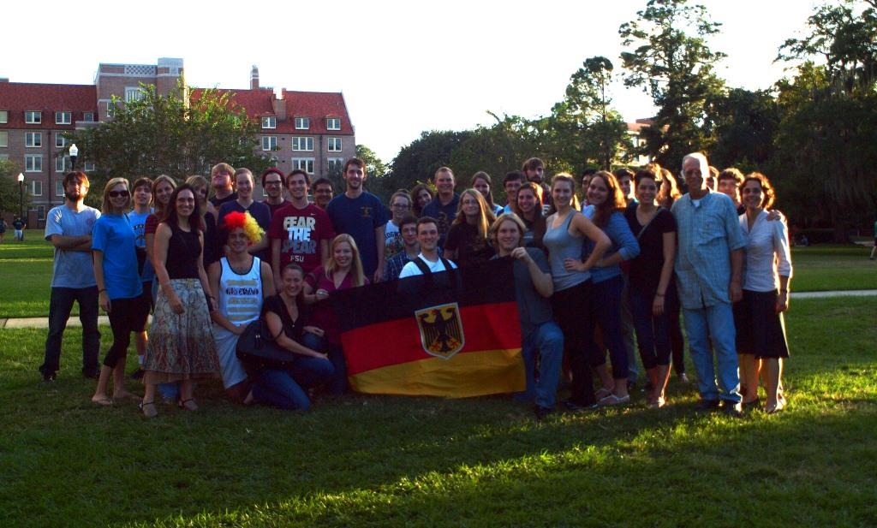

**The Department of Modern Languages offers a two-year M.A. degree program in German.** Its main objective is to introduce graduate students to all important aspects of modern German culture. Our faculty is committed to providing graduate students with a firm foundation in scholarship and an opportunity to acquire teaching experience. Our students have been accepted into some of the best Ph.D. programs in the country or pursued other professional careers, e.g. at the Deutsche Schule in Chicago or at SAP in Karlsruhe.

Expertise of German faculty and affiliated members is wide-ranging and comprises, for example: Literary studies from the eighteenth century to the present, German philosophy, history of ideas, Holocaust studies and human rights, nationalism, gender studies, performance & folklore studies, film studies. The German program encourages the pursuit of interdisciplinary interests.

**Graduate *Teaching Assistantships*** **are available for the full period of two years.**

Graduate assistants normally teach three courses per year and are paid **$13,000 p.a.** The assistantship includes tuition waivers covering approximately 85% of the total tuition costs.

The Department of Modern Languages and Linguistics will start reviewing applications for the German M.A. program **January 15, 2016**. Applications submitted by the deadline will be prioritized for financial aid purposes.

For questions about the German graduate program contact Dr. Christian Weber: [cweber@fsu.edu](mailto:cweber@fsu.edu) and check our website for more information:

<http://www.modlang.fsu.edu/Programs2/German-Program>

<http://www.modlang.fsu.edu/Graduate-Studies>

German Faculty and Affiliated Members:

*Birgit Maier-Katkin* Associate Professor (Program Coordinator, Undergrad. Student Advisor)

20th - 21st century German literature and culture; women literature; memory studies; transnational and ethnic writers; exile studies

*Christian Weber* Associate Professor (Graduate Student Advisor)

18th - 20th century German literature and philosophy, particularly Goethe and Romanticism/Idealism; aesthetics; lyric poetry; nationalism; German film

*Alina-Dana Weber* Assistant Professor (Study Abroad Advisor)

19th - 20th century German literature and culture; Cultural studies; Performance studies; Folklore; Film

*Ray Hattaway* Adjunct (Language Teaching Coordinator)

*Robert Gellately* (Professor of History)

Modern European history, particularly World War II and Cold War era

*Stephanie Leitch* (Associate Professor of Art History)

Northern European and German Art; Renaissance; History of print

*Nathan Stolzfus*, Ph.D. (Affiliated Associate Professor of History)

20th century European/German history; Cold War studies; Memories and representations of WWII

*George Williamson* (Associate Professor of History)

Nineteenth-century Germany; European religious, cultural and intellectual history

Recently taught Graduate Courses in German Studies include:

* Germanic Myths in Modern Culture

* The Magic Spell of Poetry: Introduction to German Lyric

* Goethe’s *Faust* and the Condition of Modern Man

* Poetry and Philosophy of Romanticism

* Nationalism: Imagining “Germany” as Kulturnation

* Just Reading: German Tales of Crime and Punishment

* Exile Literature and Nazi Germany

* Women Writers

* The Trouble with Rubble in German Film and Literature

* Berlin in Film & Literature

* Ethnicity in German Literature and Film

* Performances of Otherness

* German Humor in Literature and Film